
2010 Toyota Prius 60kW 650V MG2 EMOT – NCAT Test Report

SUGGESTED CITATION: 2010 Toyota Prius 60kW 650V MG2 EMOT – Test Data Package. Version 2023-04. Ann Arbor, MI: US EPA, National Vehicle and Fuel Emissions Laboratory, National Center for Advanced Technology, 2023.

NCAT – National Center for Advanced Technology

National Vehicle and Fuel Emissions Laboratory – Office of Transportation and Air Quality
U.S. Environmental Protection Agency

April 5, 2023

Table of Contents
Background 3
Purpose of Test 4
Test Article 4
Test Methodology 5
Data Set 6
Results 7
References 8

Background
The National Center for Advanced Technology (NCAT), part of EPA’s National Vehicle and Fuel Emissions Laboratory (NVFEL), assesses the effectiveness of advanced vehicles, engines, electric motors (emotors), batteries, and transmissions. As part of this work, NCAT benchmarks automotive components and compares the results with benchmarking data from other publicly available sources like published technical papers and programs run by national laboratories and universities. Benchmarking data is then used in EPA’s ALPHA (Advanced Light-Duty Powertrain & Hybrid Analysis) model to estimate greenhouse gas (GHG) emissions. ALPHA is a physics-based, forward-looking, full vehicle model, capable of simulating various vehicle types and powertrain technologies, including electrified technologies.

This test report summarizes the origin and methodology used to create a combined emotor and inverter efficiency map from benchmarking data collected from the main traction emotor and inverter from a 2010 Toyota Prius hybrid shown in Figure 1. Throughout this report and data package the term “EMOT”, a four-letter acronym internally developed by NCAT, designates the component map contains a combination of the “emotor and inverter” data.

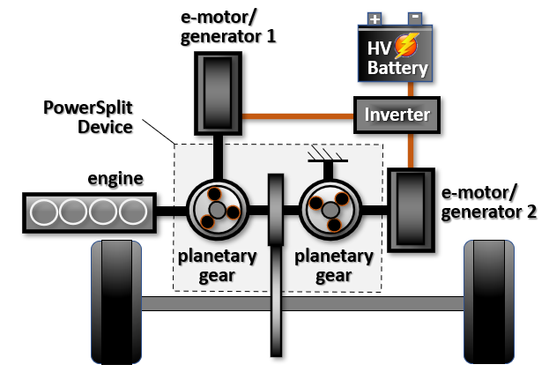

Figure 1. 2010 Toyota Prius Component Diagram

The data used to create the map originated from research performed by the U.S. Department of Energy’s (DOE) under a cooperative research effort known as the FreedomCAR Partnership. The component testing for this program was conducted by Oak Ridge National Laboratory’s (ORNL) Power Electronics and Electric Machinery Research Center (PEEMRC), a broad-based research center for power electronics and electric machinery (emotor) development. ORNL’s test report and the associated data are included in this 2010 Toyota Prius 60kW 650V MG2 EMOT – Test Data Package.

ORNL presented a summary of their component testing of the 2010 Toyota Prius emotor and inverter at the 2011 U.S. DOE Hydrogen and Fuel Cells Program and Vehicle Technologies Program Annual Merit Review and Peer Evaluation Meeting held in Washington, D.C. This presentation is included for reference in the data package: 3d- Benchmarking of Competitive Technologies Presentation by ORNL May 2011.pdf [1]. The information was also included in DOE’s FY 2011 Annual Progress Report for the Advanced Power Electronics and Electric Motors Program included for reference in the data package: 3e- FY2011 DOE Annual Progress Report Advanced Power Electronics and Electric Motors Program.pdf [2].

In addition, ORNL staff provided a detailed description of their overall electric motor test program, design, and packaging characteristic assessment, and inverter & emotor performance/efficiency benchmarking testing conducted on a 2010 Toyota Prius. This report is also included as reference in the data package: 3f- Evaluation of the 2010 Toyota Prius Hybrid Synergy Drive System by ORNL March 2011.pdf [3].

Purpose of Test
The purpose of the ORNL testing was to benchmark the efficiency of the combination of the main drive emotor and its inverter designed for the 2010 Toyota Prius. Results of ORNL’s study were used by NCAT to create an ALPHA emachine input map to be used to simulate the operation of various hybrid vehicles.

Test Article
The 2010 Toyota Prius contains a 60 kW emotor (identified as MG2 by Toyota and referred to as “motor” in the ORNL reports and presentations) paired with an inverter powered by a 270-volt lithium polymer battery. The primary electric motor (MG2) assists the engine in providing mechanical drive power for the vehicle and acts as a generator to recharge the battery during regenerative braking. Table 1 lists the key specifications of the vehicle and the test article. The ALPHA component name for this test article is “2010 Toyota Prius 60kW 650V MG2 EMOT”.

For reference, Toyota also has a secondary electric motor (identified as MG1 by Toyota and referred to as “generator” in the ORNL reports and presentations) which functions as a generator to transfer power from the engine to recharge the battery and utilize the engine as a power source to supply MG2. MG1 is not the test article in this test package.

Additionally, the inverter voltage supplied to MG2 varies from 200 – 650 Vdc when operating in the 2010 Toyota Prius, however, this mapping effort only focuses on MG2’s operation at 650 Vdc.

Table 1. Vehicle and Test Article Specifications
Model Year | 2010
Manufacturer | Toyota
Model | Prius
Curb Weight | 3050 lbs
emotor type | PMSM
emotor max power | 60 kW
emotor peak torque | 207 Nm
emotor max rated speed | 13500 rpm
Battery type | Nickel-Metal Hydride
Nominal battery voltage | 200-650 Vdc
Transmission | Electronic Continuously Variable Transmission (ECVT)
Engine | 1.8-liter 4-cylinder
Engine power | 98 hp (73 kW)
Engine and emotor power | 134 hp (100 kW)

Test Methodology
The emotor and inverter were tested using ORNL’s OPAL test setup outlined in Figure 4. A complete description of ONRL’s hardware, interface, data acquisition and setup are described in Section 3 of 3f- Evaluation of the 2010 Toyota Prius Hybrid Synergy Drive System by ORNL March 2011.pdf [3].

ORNL states in their report that “ORNL’s dynamometer test cell and Opal-RT-based speed and current feedback controller were adapted to provide the torque needed at each reference speed. Thus, as the applied torque from the dynamometer was varied manually, the controller regulated the torque producing current appropriately.” To map the inverter-emotor, ORNL bypassed Toyota’s inverter controller using its custom OPAL-RT system to control the output of Toyota’s inverter to drive Toyota’s emotor. This process is used to determine efficiency across the entire torque-speed range of the emotor.
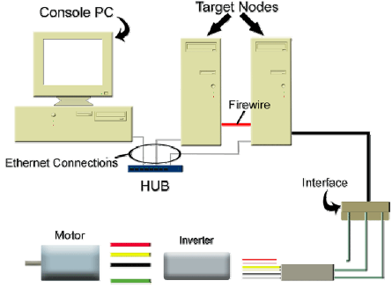
Figure 4. ORNL’s Opal-RT Controller and Interface System

Data Set
After installation in ORNL’s dynamometer cell, data were collected at stable emotor/inverter operation conditions over a range of steady state torque and speed operating points for the efficiency contour map of the combined emotor and inverter assembly. These mapping points include a series of regularly spaced points. Figure 5 below shows the contour map image of this data as included in ORNL’s merit review presentation and report: 3d- Benchmarking of Competitive Technologies Presentation by ORNL May 2011.pdf [1] and 3e- FY2011 DOE Annual Progress Report Advanced Power Electronics and Electric Motors Program.pdf [2].

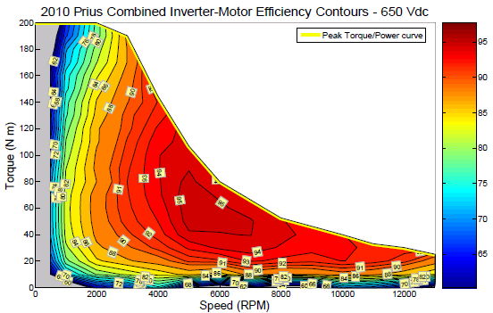
Figure 5. ORNL’s Efficiency Contour Map of the Combined Emotor & Inverter Assembly

Results
Using the ORNL efficiency data and the process described in the html file: 3a- 2010 Toyota Prius 60kW 650V MG2 EMOT - ALPHA Generation Process.html, NCAT created the ALPHA input map shown in Figure 6 which is also available as a standalone image in the complete data package. Note that ORNL only gathered data of MG2 operating in the motoring mode. That data was then subsequently “mirrored” to provide an estimate of MG2’s performance when operating in regen mode as detailed in the html file referenced above.

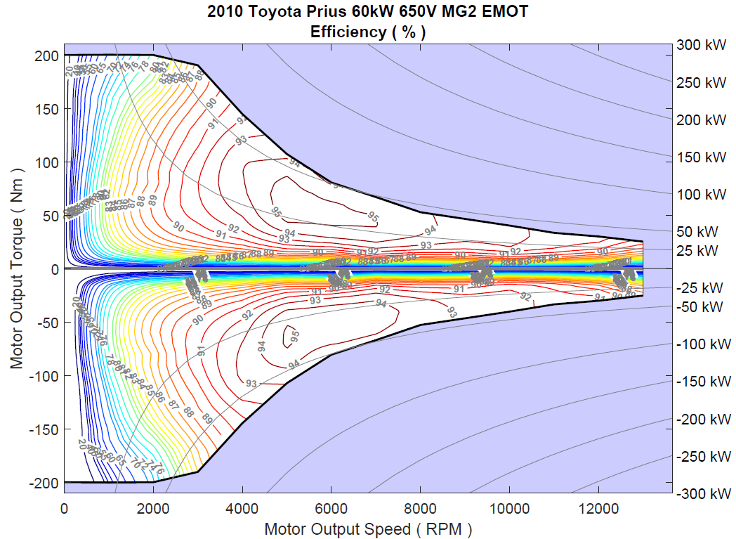

Figure 6. NCAT’s ALPHA Efficiency Contour Map of the Combined Emotor and Inverter Assembly from the 2010 Toyota Prius MG2

References

[1] T. A. Burress. (May 10, 2011) “Benchmarking of Competitive Technologies,” presented at 2011 U.S. DOE Hydrogen and Fuel Cells Program and Vehicle Technologies Program Annual Merit Review and Peer Evaluation Meeting, Washington, D.C. Available at
https://www.energy.gov/sites/prod/files/2014/03/f10/ape006_burress_2011_o.pdf.

[2] U.S. Department of Energy, Energy Efficiency and Renewable Energy Vehicle Technologies Office. (January 2012) FY2011 Annual Progress Report for the Advanced Power Electronics and Electric Motors Program. Document DOE/EE-0676. Available at https://www.energy.gov/eere/vehicles/articles/advanced-power-electronics-and-electric-motors-rd-2011-annual-progress.

[3] T. A. Burress, S. L. Campbell, C. L. Coomer, C. W. Ayers, A. A. Wereszczak, J. P. Cunningham, L. D. Marlino, L. E. Seiber, and H. T. Lin. (March 2011) Evaluation of the 2010 Toyota Prius Hybrid Synergy Drive System. Document ORNL/TM-2010/253. Available at https://info.ornl.gov/sites/publications/files/pub26762.pdf.

.

